Day 5: 21 September 2024

To open h2 database

<http://localhost:9090/h2-console>

Creating table in H2 database

create table login(emailid varchar(50) primary key,password varchar(50));

To open the application

<http://localhost:9090>

We can use ORM concept to connect the database using Java or any other programming language..

ORM : Object Relation Mapping

Limitation of JDBC or JdbcTemplate

1. JDBC doesn’t store Java object as well as doesn’t retrieve java object. in DAO layer we need to convert Java object into SQL format and vice-versa.
2. JDBC throw checked exception. The exception hierarchy is database depends. If we change database different database can use different exception name.
3. JDBC use SQL language. SQL is database dependents.
4. JDBC doesn’t support is a (inheritance) and has relationship (creating inside one class another class object).

ORM is concept like a OOPs.

In ORM we need Java Bean class mandatory.

Programming side Object using Java Bean in RDMBS table is known relation

@Entity

@Table(name=”productsdetails”)

class Product { Product table

@Id PK

@Column(name=”productid)

pid,pame,price variable PID,PName,Price column

}

Mapping

Product (class) ----- Product (table )

Pid ---- PID with data type PK

PName -- PNAME with data type

Price PRICE with data type

Records

Object

Product p = new Product(100,”TV”,55000) 100,TV,55000 Old version we were/are doing configuration using xml

New version we are using annotation.

JDBC doesn’t create table for use we need to write some script file to create the table.

But using ORM with simple property value we can create the table.

Hibernate and JPA are type of ORM tools.

Hibernate : Hibernate is an open source framework provided by JBoss.

JPA (Java persistence API): JPA is a technology it not a framework. JPA is a part of Java technologies. JPA also known as type of EJB.

JPA is specification as well as provided implementation

Hibernate is one of the implementation for JPA.

Hibernate Vs JPA

hibernate.cfg.xml persistence.xml

drivername,url,username and password

SessionFactory interface EntityManagerFactory interface

Like a Connection in Jdbc.

Session EntityManager

Both are interface like Statement or PreparedStatement in JDBC

Or JdbcTemplate

save we store record using these method persist

Like insert query

delete remove

like delete query

update merge

like update query

get find

select with PK

Hibernate and JPA use same annotation.

Core Java with JDBC or JPA or Hibernate

Servlet /JSP with JDBC or Jpa or Hibernate

Spring framework with JDBC or JPA or Hibernate we need to provide all configuration in xml file.

Spring boot we can use Jdbc or JdbcTemplate or JPA . spring boot after 2.52 version onward Hibernate API deprecated. Spring Framework support JPA orm boot. It provided JPA Starter with Hibernate. But using Jpa API not hibernate API.

Spring framework or spring boot didn’t provide any ORM tool.

They allow use to integrate existing ORM tool or technologies like hibernate or jpa.

If we use ORM tool like JPA or hibernate without spring framework or boot. We can’t use IOC and DI.

Spring framework doesn’t provide ORM tool. So when we combine these two technologies or framework spring boot provide IOC and DI and JPA/Hibernate provide ORM.

Spring ORM modules.

Creating simple spring boot project using spring <https://start.spring.io/>

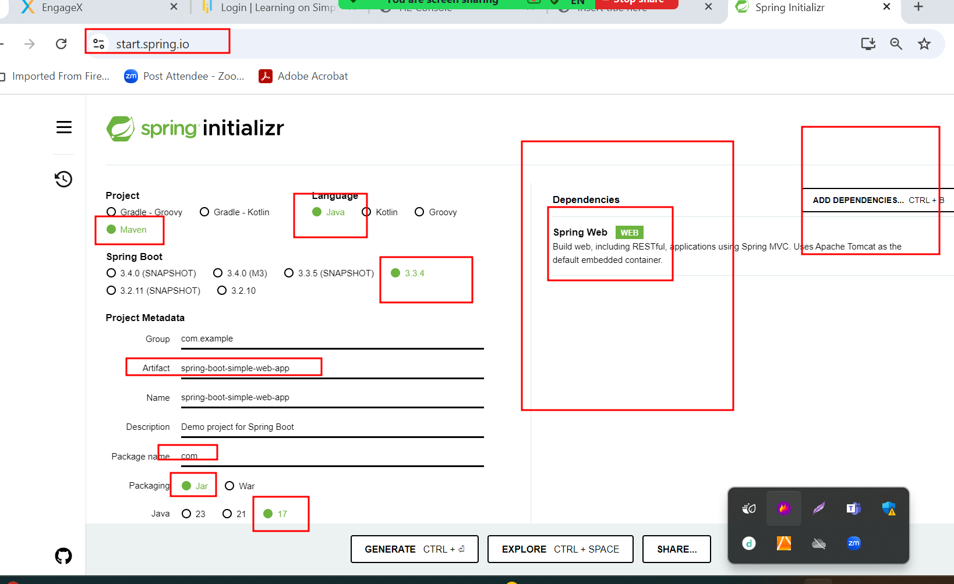

Creating another project with starter as

Web and thymeleaf

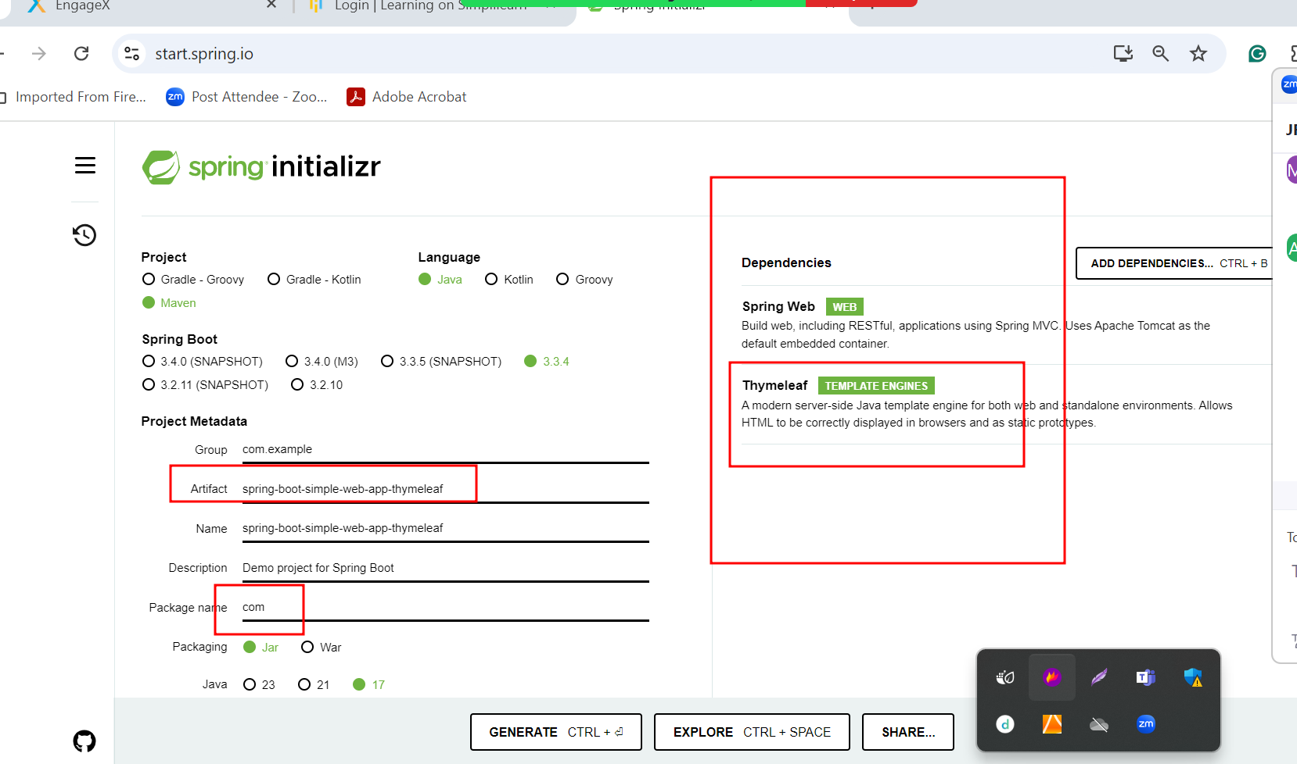

Dynamic coding using thymeleaf page